**Sport NZ Rural Travel Fund**

The Sport NZ Rural Travel Fund is a partnership between Sport NZ and territorial authorities to assist the development of junior sport in rural communities by providing a travel subsidy.

Application for the rural travel fund is open to rural sports clubs and rural school teams with young people aged between 5 and 18 years who require subsidies to assist with transport expenses to local sporting competitions.

Funding cannot be provided for the purpose of travel to regional or national events and funding cannot be provided for individuals. Funding is for regular local competition e.g. Saturday morning or weeknight games.

The following criteria shall be applied when considering applications for funding. School club teams and sport club teams are defined as:

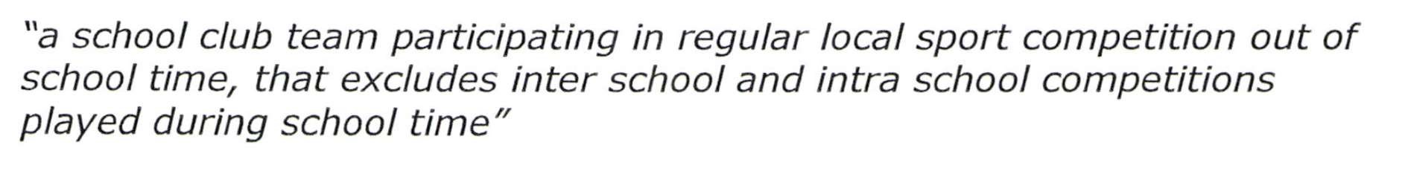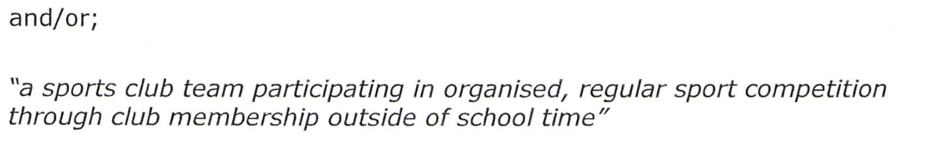

Sport NZ requires organisations that receive funding to return an accountability form showing proof of purchases made within the funding period and attach any receipts.

**Please return completed forms to the administrator by 4.00pm on Thursday 27 March 2025**

Contact: Lindsay Tumata, PO Box 44, Ōpōtiki or 70 Bridge Street, Ōpōtiki, PH 07 3153031 or email: infocentre@odc.govt.nz

**Application No. (Office use only)**

**SPORT NZ RURAL TRAVEL FUND APPLICATION FORM 2024 - 2025**

1. **Details**

Name of organisation: ________________________________________

Contact person: ________________________________________

Postal address: ________________________________________

PO Box address: ________________________________________

Telephone: __________________Email: _________________

**B. Contact Names**

**Please provide**

1. Name __________________________ Phone __________________

1. Name __________________________ Phone __________________

**C. Organisation Details**

Are you a club or a school?

1. How many members belong to your club/school?
2. How many participants aged between 5 & 18 will this travel subsidy benefit?
3. How many participants are aged between 5-11 yrs
4. How many participants are aged between 12-18 yrs
5. Please detail how many applicants are female
6. Please detail how many applicants are male
7. Does your application involve a partnership with a local school / club YES/ NO
8. What is this funding going to be used for? (Briefly explain)

__________________________________________________________________________

__________________________________________________________________________

__________________________________________________________________________

1. Do you have any disabled individuals who are being supported by this fund?

a. If yes, how many will receive support from the RTF

1. What percentage of your members live in the vicinity of the local authority you are applying to for the rural travel fund?

___________%

**D. Financial Details**

1. Are you registered for GST? YES / NO

(If yes please write your GST Number in the space provided below)

GST NO.

|  |  |  |  |  |  |  |  |
| --- | --- | --- | --- | --- | --- | --- | --- |
|  |  |  |  |  |  |  |  |

1. How much money are you applying for?

$____________ Sport NZ funding

$____________ other funders

$____________ your contribution

$____________ TOTAL

1. If you have applied for funding from other organisations, please supply details - *refer to Table 1 below.*

Table 1

|  |  |  |
| --- | --- | --- |
| Organisation - *(including other councils)* | Amount requested ($) | Results date (*if known*) |
|  |  |  |
|  |  |  |
|  |  |  |
|  |  |  |
|  |  |  |
|  |  |  |

1. Do you have endorsement from your local affiliated club/school for this application for funding? (this is only relevant if the group applying is the regional body).

YES/ NO (briefly explain and attach evidence of this)

________________________________________________________________________

________________________________________________________________________

**E. Declaration**

**We hereby declare that the information supplied here on behalf of our organisation is correct?**

We consent to _________________________ authority collecting the personal contact details and information provided in this application, retaining and using these details and disclosing them to Sport NZ for the purpose of review of the rural travel fund. This consent is given in accordance with the Privacy Act 1993.

* 1. Name:

Position in organisation / title: __

Signature: Date: _

* 1. Name: __________________________________________________

Position in organisation / title: _

Signature: Date: _

Please attach:

1. Latest financial statements from your organisation (i.e. P&L, financial statement)
2. A deposit slip (in case your application is approved)
3. Evidence of your endorsement from your local affiliated club/school (if required)

Checklist:

1. Have you answered every question?
2. Have you attached the relevant documents with your application?
3. Send your application form with the relevant documents to your local authority by 4pm, Thursday 27th March 2025.